WEEK: 5
Applying Deep Learning Models in the Field of Natural Language Processing

Definition:
Applying Deep Learning Models in Natural Language Processing (NLP) refers to the use of neural network-based models such as CNN, RNN, LSTM, GRU, and Transformers to enable computers to understand, process, and generate human language. These models learn patterns and relationships from large amounts of text data and are used for tasks such as text classification, sentiment analysis, machine translation, speech recognition, question answering, text generation, and chatbots.

AIM:
To write a Python program that applies Deep Learning models in the field of Natural Language Processing (NLP).

ALGORITHM:
- Start the program.
- Import the necessary libraries and dataset.
- Build the model using a DNN (with embeddings).
- Compile and train the model.
- Take dynamic user input and predict the emotion.
- Stop the program.

INPUT: Text data with labeled emotions (File Name: train.txt)
OUTPUT: Predicted categories: Sadness, Joy, Love, Anger, Surprise, Fear

train.txt: (download from here)
https://www.kaggle.com/datasets/praveengovi/emotions-dataset-for-nlp?resource=download

PROGRAM:
import numpy as np
import pandas as pd
from tensorflow.keras.preprocessing.text import Tokenizer
from tensorflow.keras.preprocessing.sequence import pad_sequences
from sklearn.preprocessing import LabelEncoder
from sklearn.model_selection import train_test_split
from keras.models import Sequential
from keras.layers import Embedding, Flatten, Dense
from keras.utils import to_categorical
# Load dataset
data = pd.read_csv("train.txt", sep=';', header=None, names=["Text", "Emotions"])
print("Sample Data:")
print(data.head())
texts = data["Text"].tolist()
labels = data["Emotions"].tolist()
# Tokenize
tokenizer = Tokenizer()
tokenizer.fit_on_texts(texts)
sequences = tokenizer.texts_to_sequences(texts)
max_length = max(len(seq) for seq in sequences)
padded_sequences = pad_sequences(sequences, maxlen=max_length)
# Encode labels
label_encoder = LabelEncoder()
labels_encoded = label_encoder.fit_transform(labels)
one_hot_labels = to_categorical(labels_encoded)
# Split dataset
xtrain, xtest, ytrain, ytest = train_test_split(padded_sequences, one_hot_labels, test_size=0.2)
# Build model
model = Sequential()
model.add(Embedding(input_dim=len(tokenizer.word_index)+1, output_dim=128, input_length=max_length))
model.add(Flatten())
model.add(Dense(128, activation='relu'))
model.add(Dense(len(one_hot_labels[0]), activation='softmax'))
model.compile(optimizer='adam', loss='categorical_crossentropy', metrics=['accuracy'])
model.fit(xtrain, ytrain, epochs=10, batch_size=32, validation_data=(xtest, ytest))
# Predict with dynamic input
while True:
input_text = input("\nEnter a sentence (or type 'exit' to quit): ")
if input_text.lower() == 'exit':
break
input_seq = tokenizer.texts_to_sequences([input_text])
padded_input = pad_sequences(input_seq, maxlen=max_length)
prediction = model.predict(padded_input, verbose=0)
predicted_label = label_encoder.inverse_transform([np.argmax(prediction)])
print(f"Predicted Emotion: {predicted_label[0]}")

Outputs:
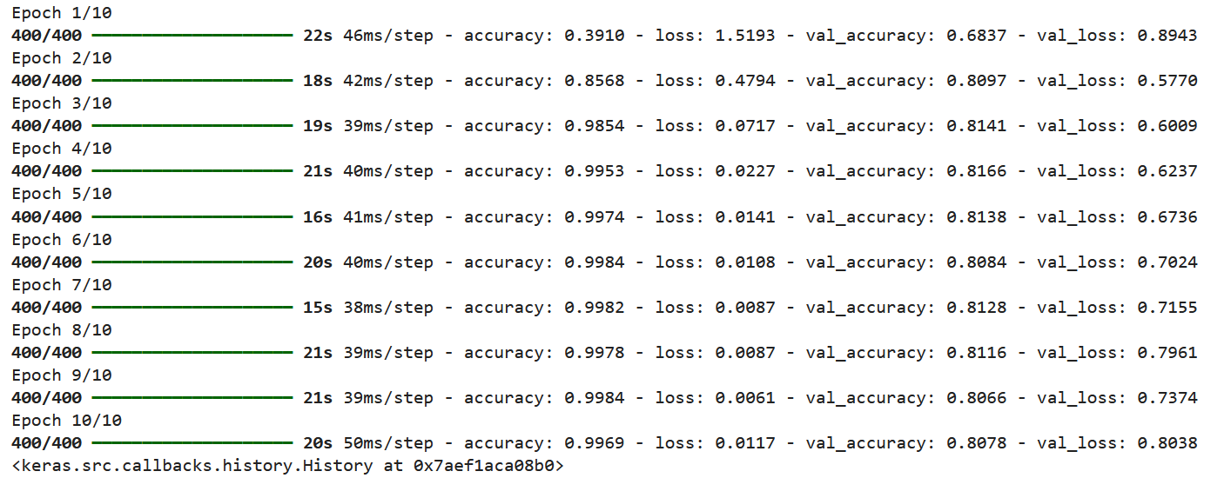

#Predicted the Result-01:
input_text = "She was exhausted last night"
OUTPUT:
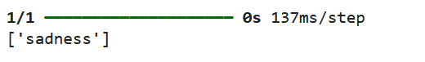

#Predicted the Result-02:
input_text = "I will feel happy"
OUTPUT:
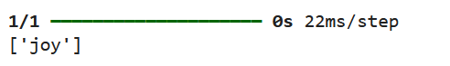

#Predicted the Result-03:
input_text = "He met with an accident"
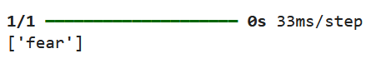
#Predicted the Result-04
input_text = " i am feeling grouchy"
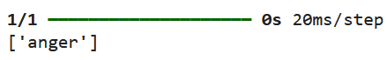

#Predicted the Result-05
input_text = "i am ever feeling nostalgic"
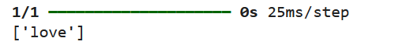

Result:
Thus the deep learning models are applied in the field NLP and the models was evaluated and predicted the results successfully.

